Emerald Insight平台升級通知信

Emerald Insight註冊用戶您好，

Emerald Insight將於2019年6月30日推出新的平台介面，平台網址不會變更，將帶給大家更好的用戶體驗。

Emerald Insight新平台優勢：
- 提昇更好的使用經驗，如: 更精確的檢索結果，更快更穩定的連線速度
- 因應未來資訊形態的多樣性 (期刊/書/個案/影片/動畫) 提供簡潔易於上手的使用界面

平台於6月29日進行轉換，故6月29日～6月30日會有斷線的狀況 (台灣時間：6/29 AM:7:00~7/1 AM:7:00)，目前網站上已有公告提示，如下圖
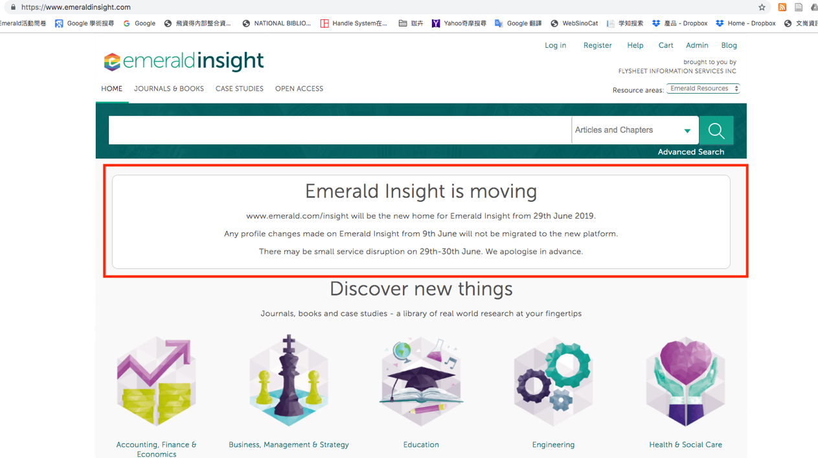

6月9日起為平台轉換緩衝期間，個人Profile的更新不會自動更新至新平台，且6月18日至新平台上線期間，將無法提供新知通告(Alerts)。

以下個人Profile內容將被轉移：
1. 最喜歡的內容(Favourited content)
2. 新知通告(Alerts)：摘要和主題、主題領域新聞、目錄、引文和EarlyCite文章

※個人已儲存之新知通告(Alerts)將不會轉移，因為這些通告與新平台上實施的檢索演算法並不兼容

附上Emerald原文信件供參：

Hello
Important Update to the My Profile Section
As a registrant on Emerald Insight, you may be aware that we are launching our new digital platform on 30 June 2019. We need to make you aware of some changes to the existing site which might affect you as we near the launch of the new platform.
We will be migrating all profile account details to the new platform. However, we will not be migrating any profile changes made on emeraldinsight.com after Sunday 9 June 2019 and you will not receive any alerts after Tuesday 18 June 2019 until the functionality is enabled on the new platform.
When the new platform launches, there will be a short time before the new user profile section launches. A communication giving detailed instructions will be sent when this function is enabled.
The following will be transferred:
- Favourited content
- Alerts: digest and subject, subject area news, table of contents, citation and EarlyCite articles
- Saved search alerts will not be migrated as these are not compatible with the more sophisticated search algorithm implemented on the new platform.
For more information, please read our FAQ document which can be found here, and if you have any questions please contact our team.
Please visit our BETA site to explore the new platform before it launches.
Kind regards
Emerald Team
Emerald Publishing
T: +44 (0)1274 777700 F: +44 (0)1274 785201

